Aggregation technique evaluation

Simon Lidberg

2021-01-20

# Introduction

The experiment has been setup to evaluate the limits of the model simplification technique. This is accomplished by running 17 experiments with 4 input parameters and 8 outputs for comparison.

Three different models are used. *Detailed* is a model generated from a number of buffer-machine pairs, determined by the parameter **NumberMachines** and the buffersize is set by the parameter **BufferSize**. After simulation of this model, the outputs are used to construct two aggregated models, *Aggregated* and *AggregatedPlace*.

The inputs needed to *Aggregated* and *AggregatedPlace* are Cycle Time (CT), Availability $α$, Mean down time (MDT), minimum Lead time (MinLT), average WIP (AvgWIP) and maximum WIP (MaxWIP). MinLT is calculated by $CT*NumberMachines+BufferSize*10$, where 10 is the transport time for each buffer place, in seconds. $α$ is calculated by analyzing the interdeparture times from the last station in the *Detailed* model. Each time the departure time is above CT, we increment a counter and use this as a measure of when the line has not delivered according to plan.

*Aggregated* is the regular aggregation technique from Pehrsson (2015), and *AggregatedPlace* switches to a PlaceBuffer object as the LineWIP.

**InputDistribution** controls the failure calculation for the LineInput object. Either LineInput uses no failures, the same Availability as the LineOutput, or it uses the square root of the value. This increases the availability on the input compared to just using Avb. Each station and buffer in the *Detailed* model uses the same attributes.

Parameters for each station in the *Detailed* model

|  |  |  |
| --- | --- | --- |
|  | Detailed_98 | Detailed_85 |
| CT | 60 | 60 |
| Avb | 98 | 85 |
| MDT | 600 | 600 |

## Model algorithm

*Detailed* is automatically built in Plant Simulation after new inputs have been assigned. The result is a series of machine/buffer pairs, where each machine has failures set to the same processing time, availability value and mean down time value. The buffers are initialized with **BufferSize** and with a processing time of **BufferSize** * CT. This model represents a level of granularity where each workstation and buffer is modelled, the level most simulation models are built for a production line. This approach only evaluates complexity in number of entities and components, while for real models, several other forms of complexity will increase the running time further. Other forms of complexity are the quantity of connections and the quantity of calculations needed to determine part routing or defining parameters (Zee 2017).

### Experiment setup

5-500 **NumberMachines** 1-10 **BufferSize** 1-3 **InputDistribution** No Failure, Avb or sqrt(Avb/100)

### Distributed experiment functionality

# Runtime Evaluation

Shows the runtime in seconds for the different models compared to the size of the model. Each **BufferSize** setting, 1-10, is shown by a connected line with a fitted function to show the growth.

## 98

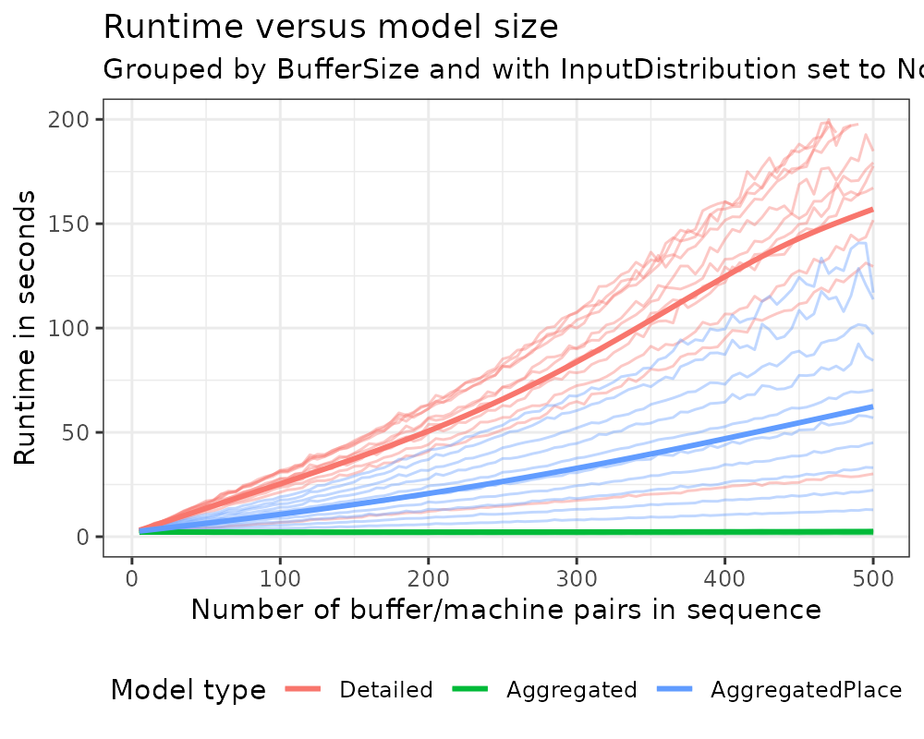

## 85

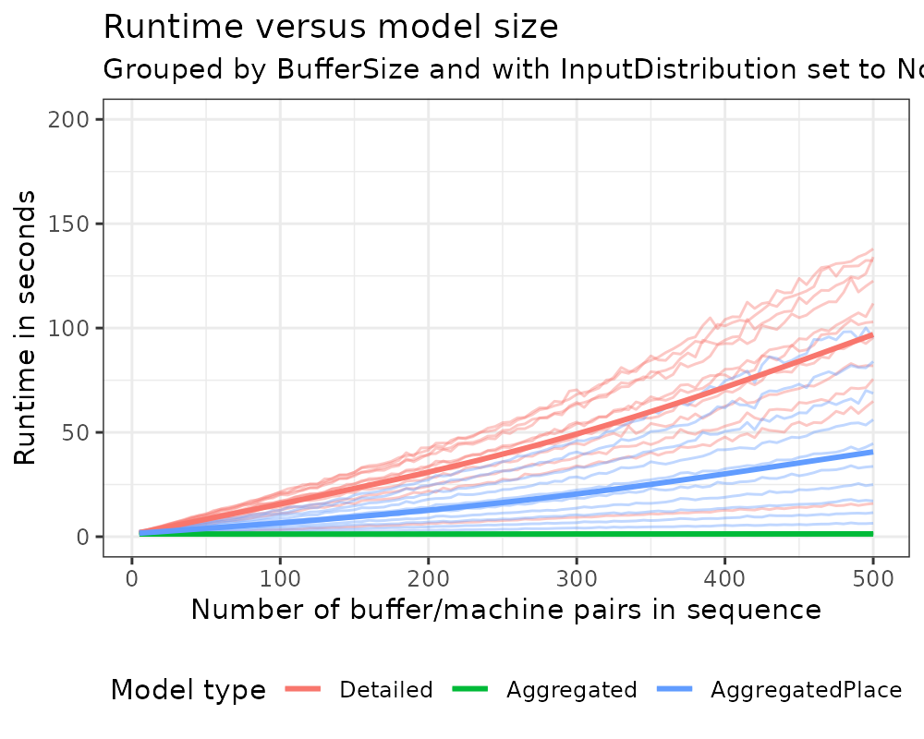

*Detailed* exhibits exponential growth, while *AggregatedPlace* shows linear growth, and *Aggregated* is near constant.

# Parameter Evaluation

Comparing the difference when setting the failure of **LineInput** to No Failure, Avb, or to sqrt(Avb/100). Compared to the performance of *Detailed* indicated by a horizontal line where $y=1$.

## LT

### Average

#### Avb 98

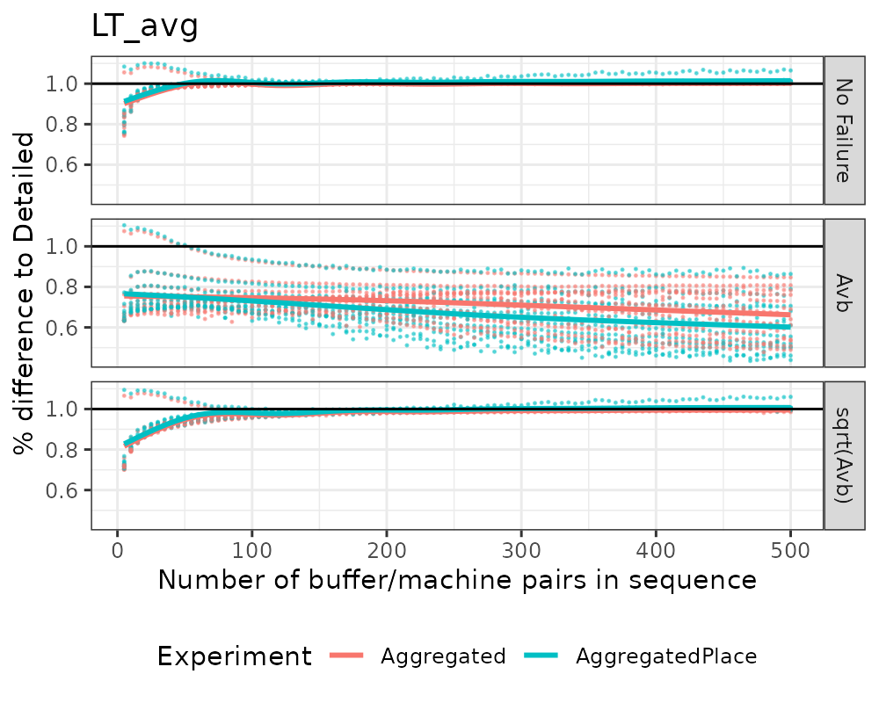

#### Avb 85

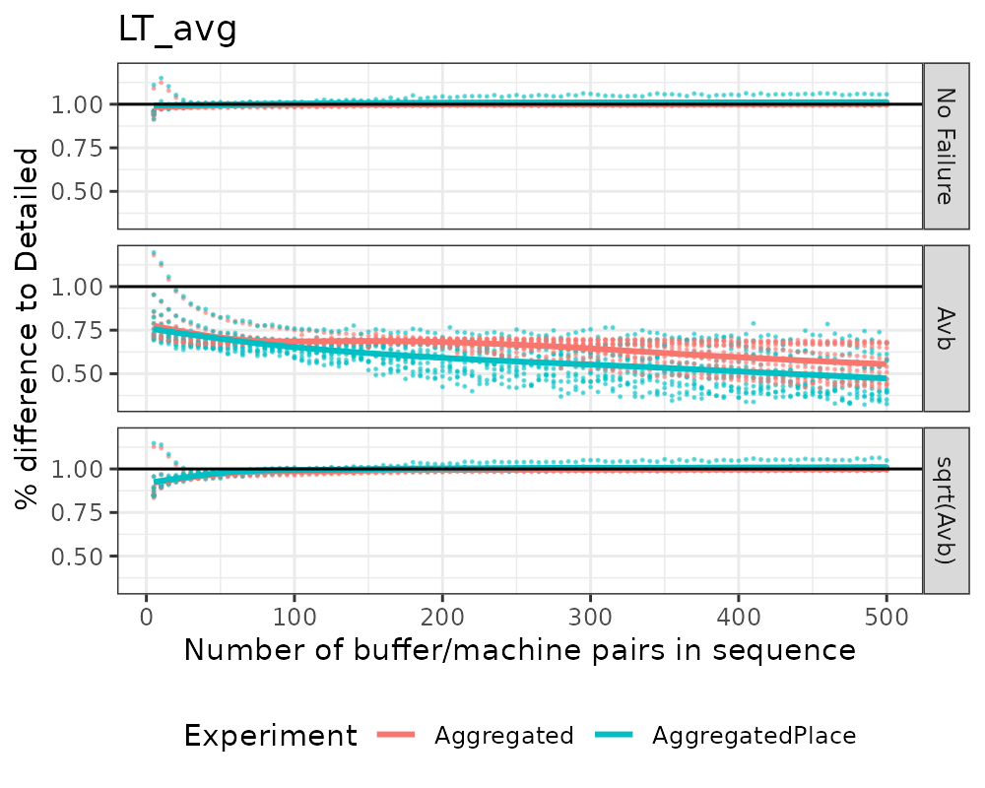

### Min

#### Avb 98

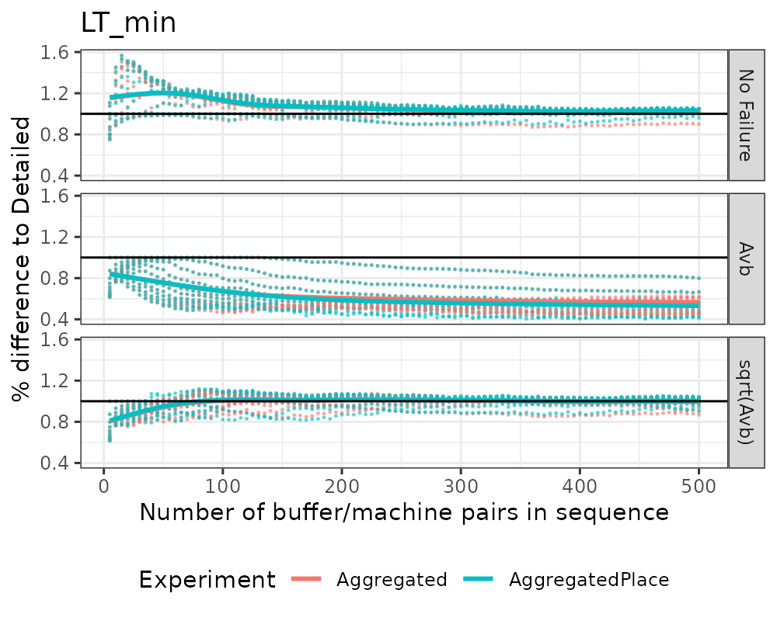

#### Avb 85

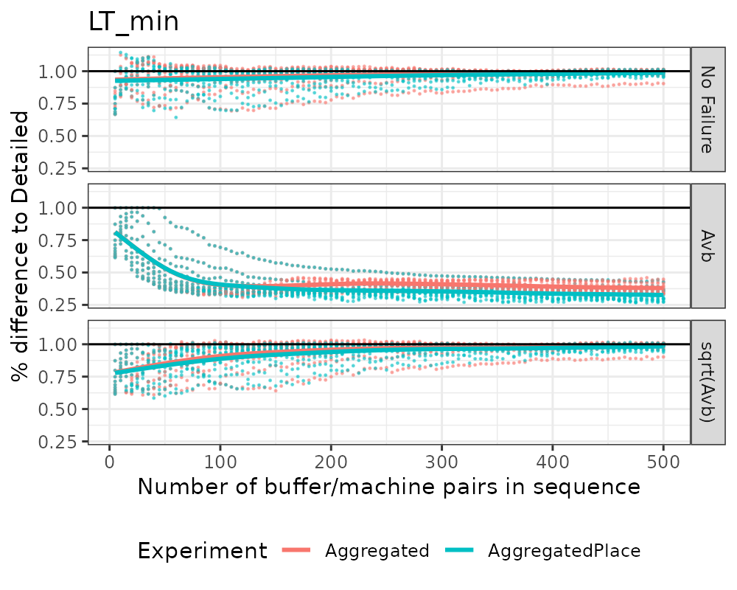

### Max

#### Avb 98

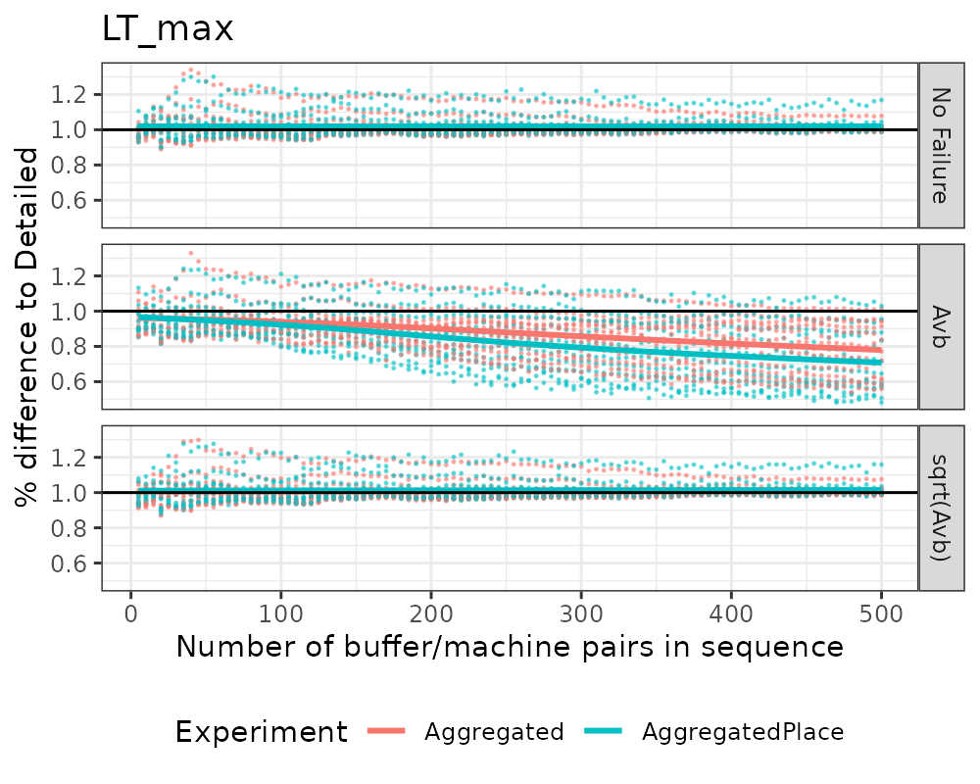

#### Avb 85

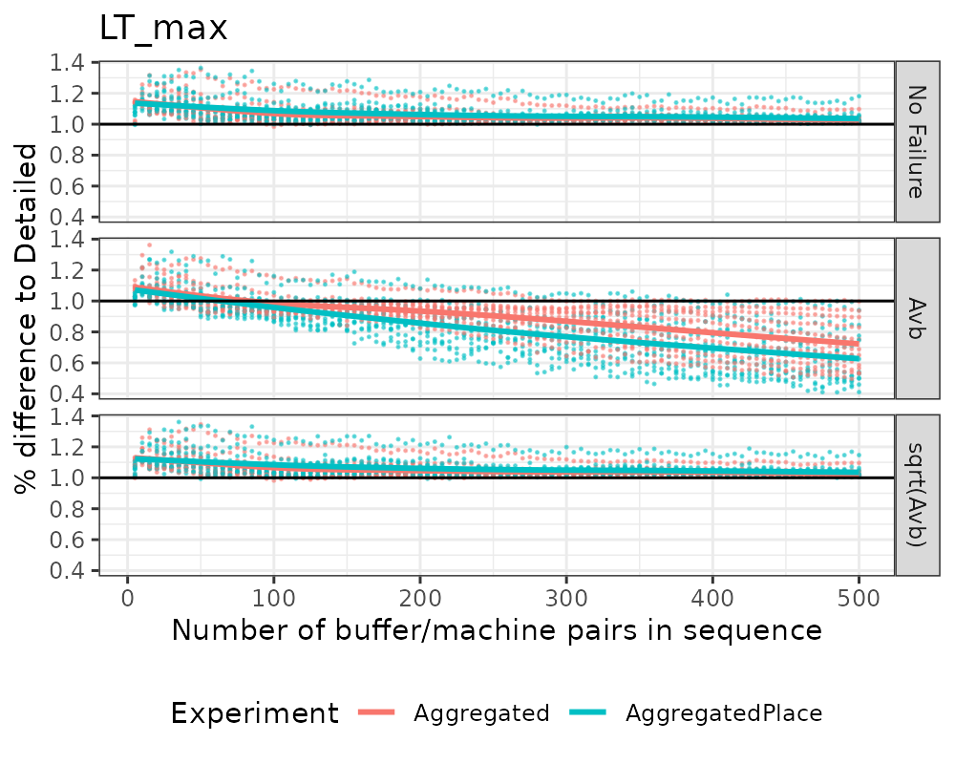

## WIP

### Average

#### Avb 98

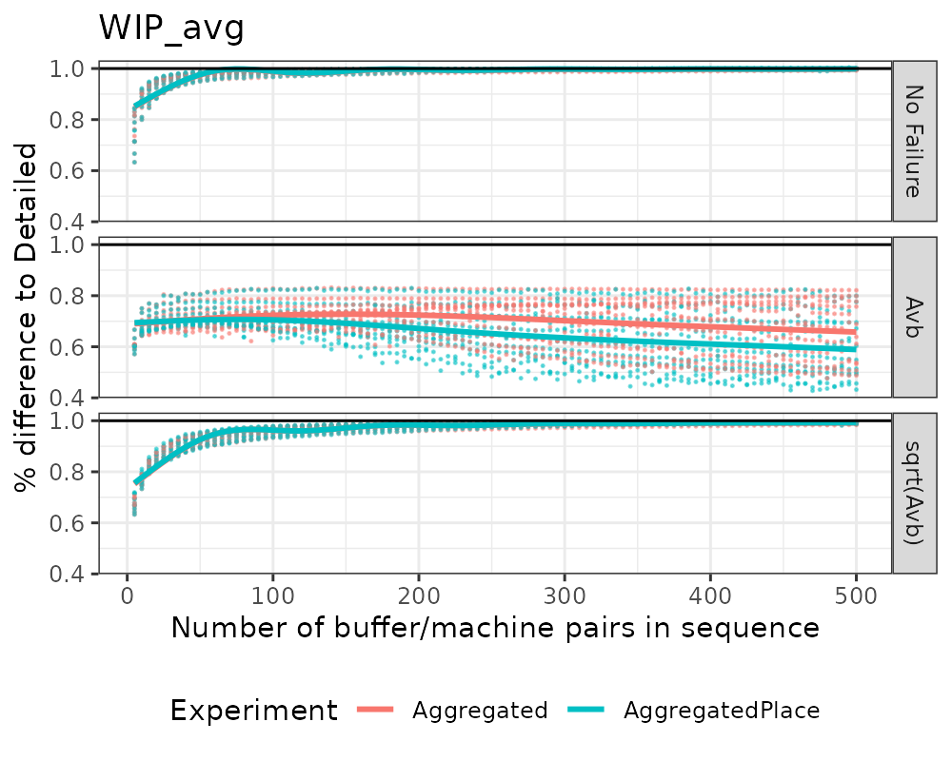

#### Avb 85

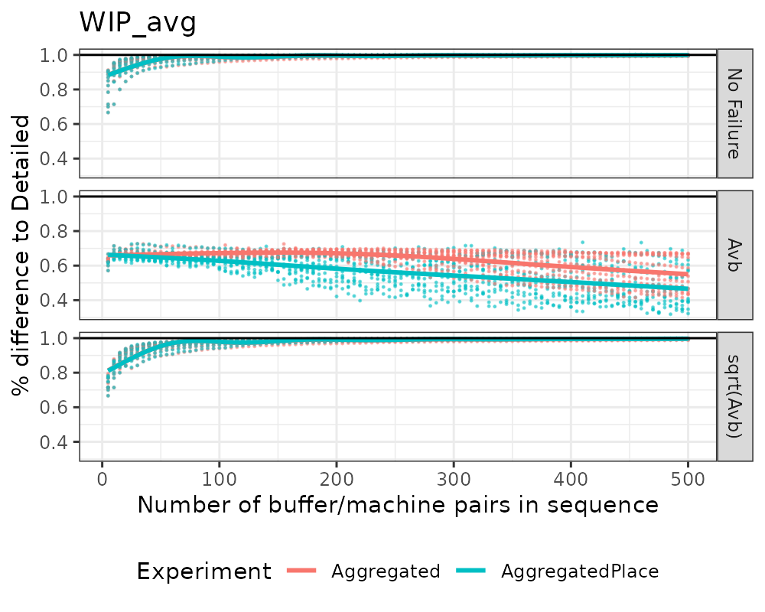

### Min

#### Avb 98

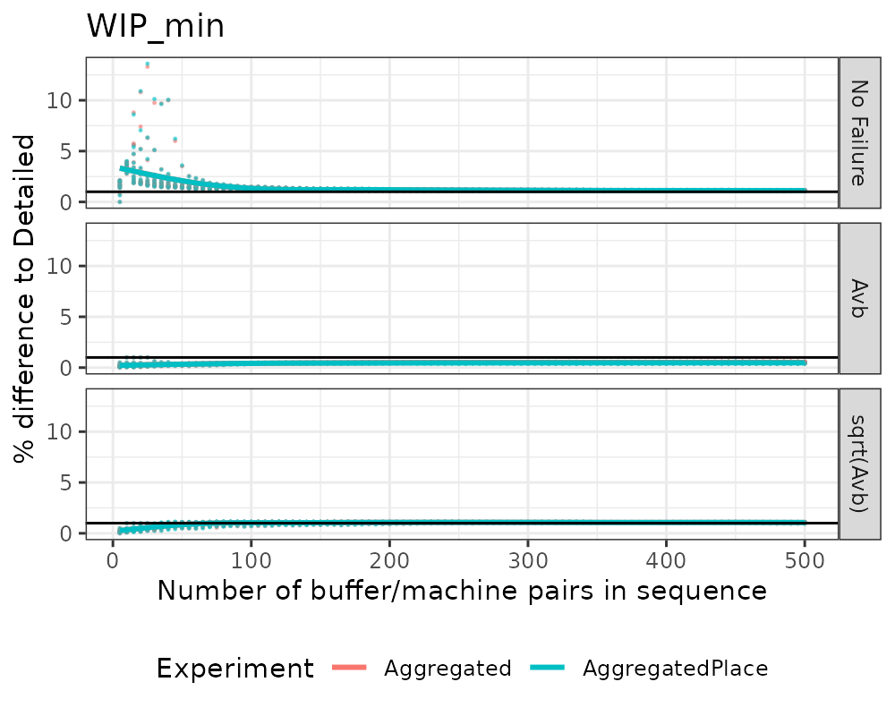

#### Avb 85

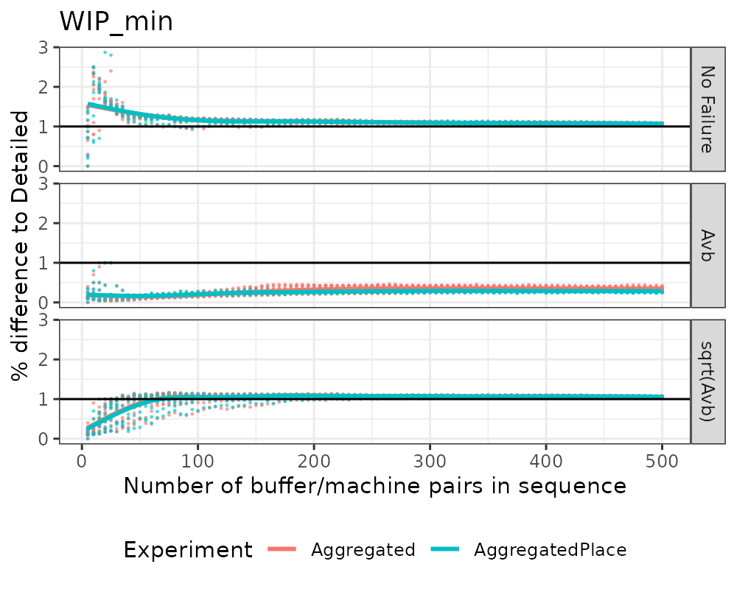

### Max

#### Avb 98

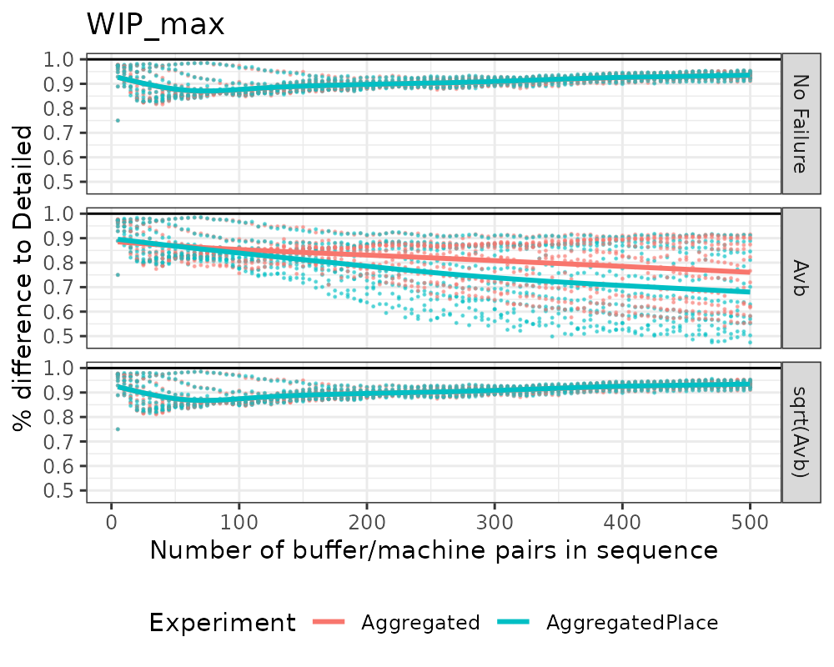

#### Avb 85

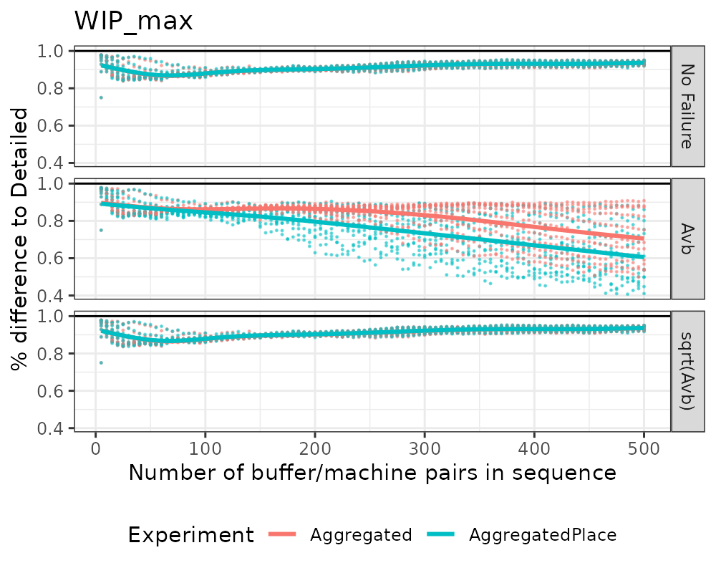

## JPH

### Average

#### Avb 98

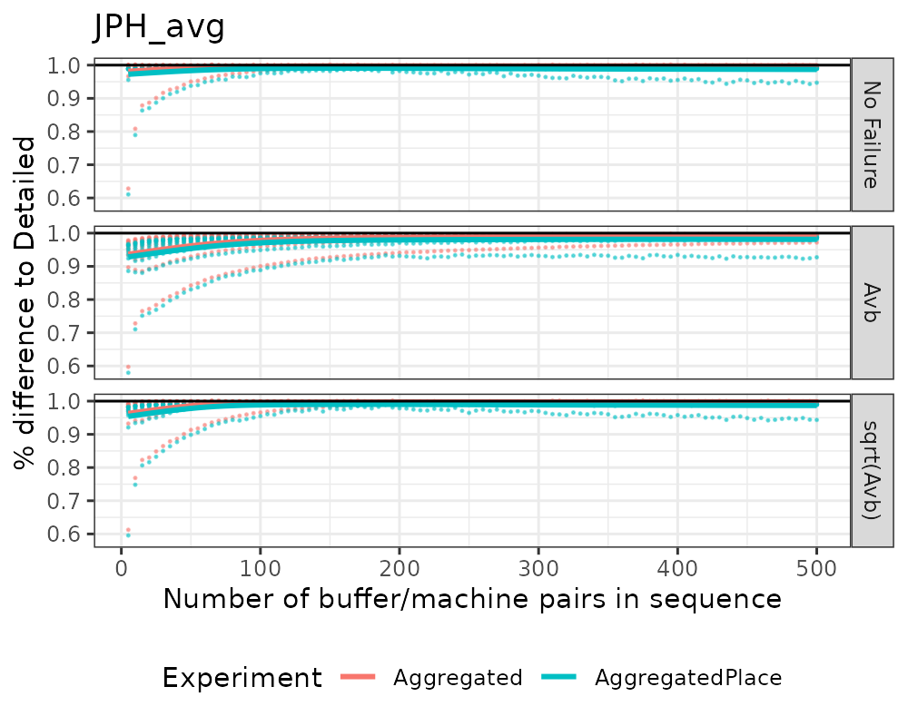

#### Avb 85

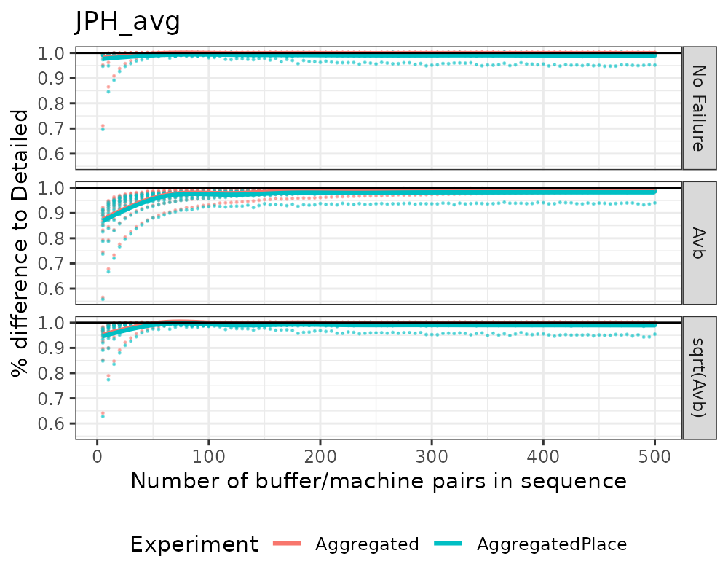

### Min

#### Avb 98

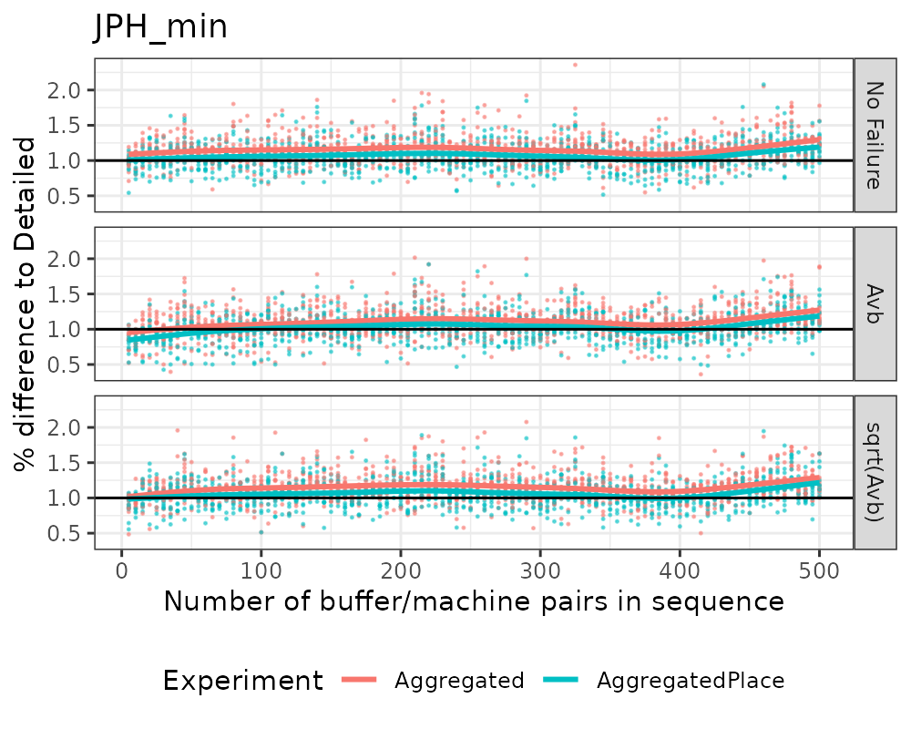

#### Avb 85

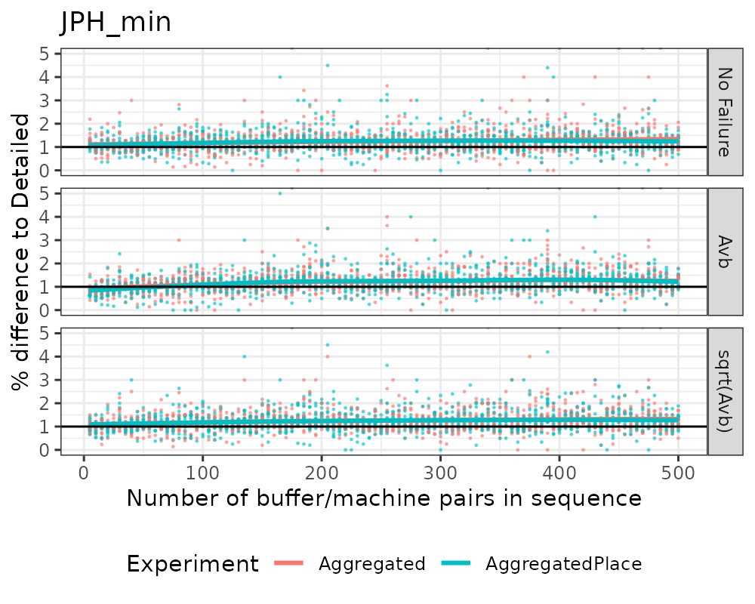

### Max

#### Avb 98

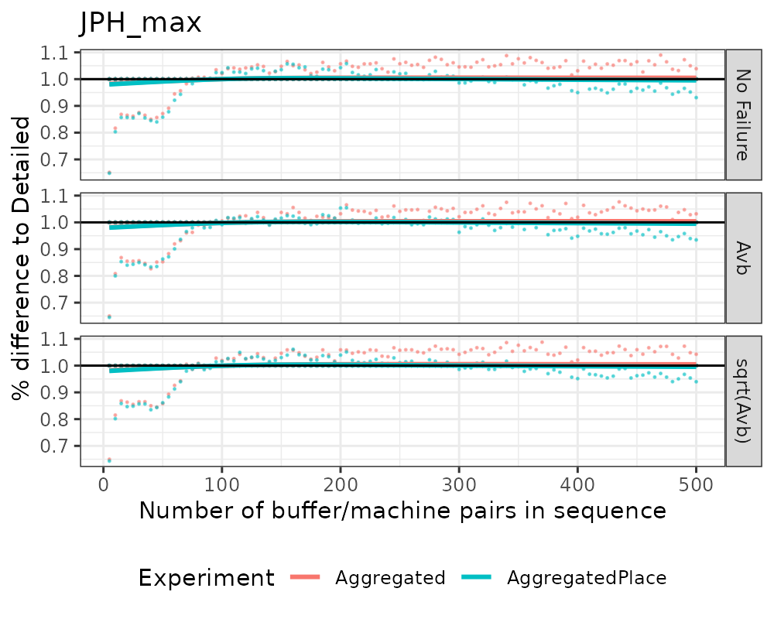

#### Avb 85

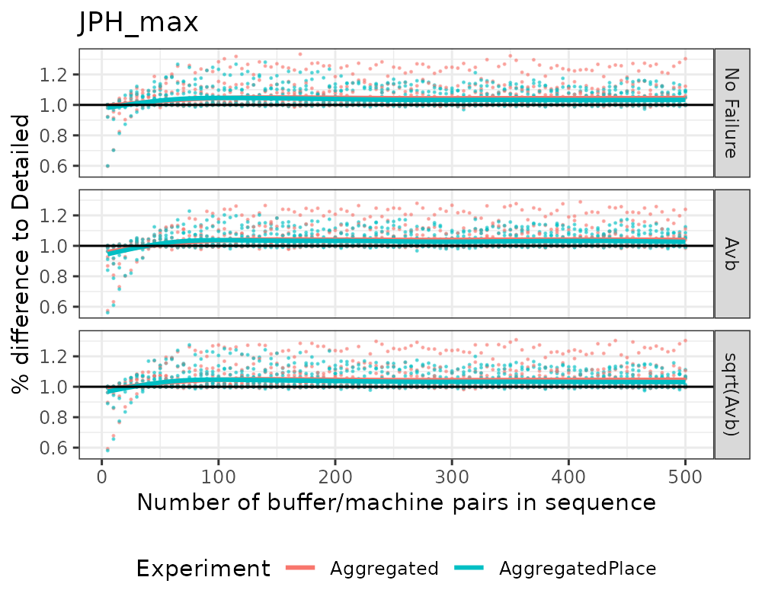

# Difference compared to buffer size

Performance of *Detailed* indicated by a horizontal line where $y=1$.

## LT

### Avb 98

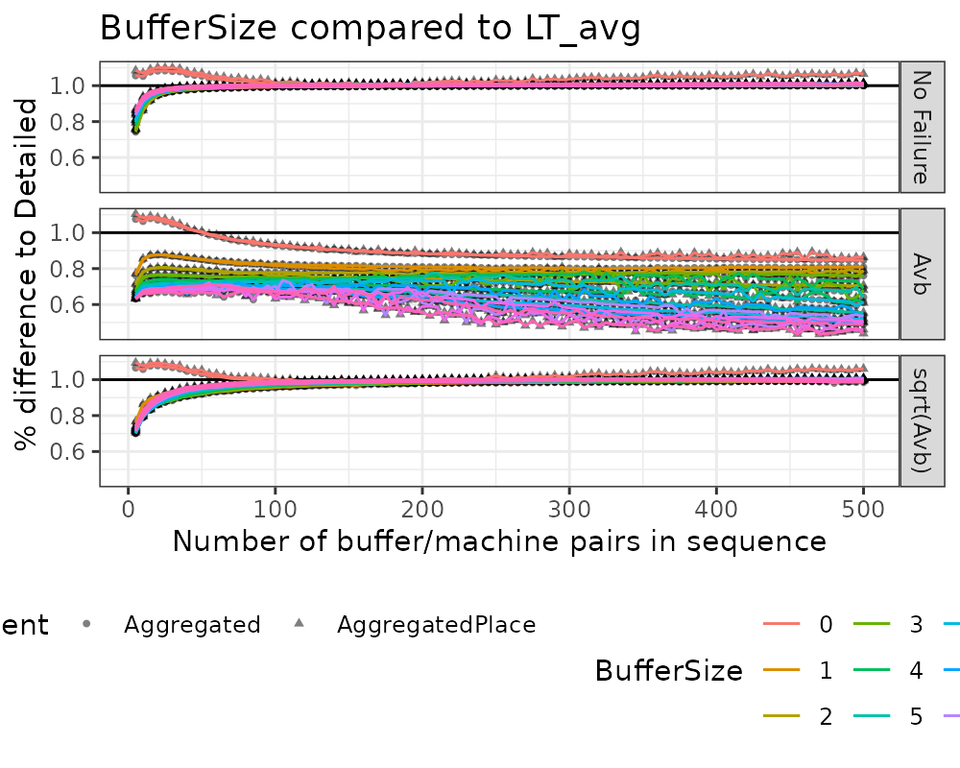

### Avb 85

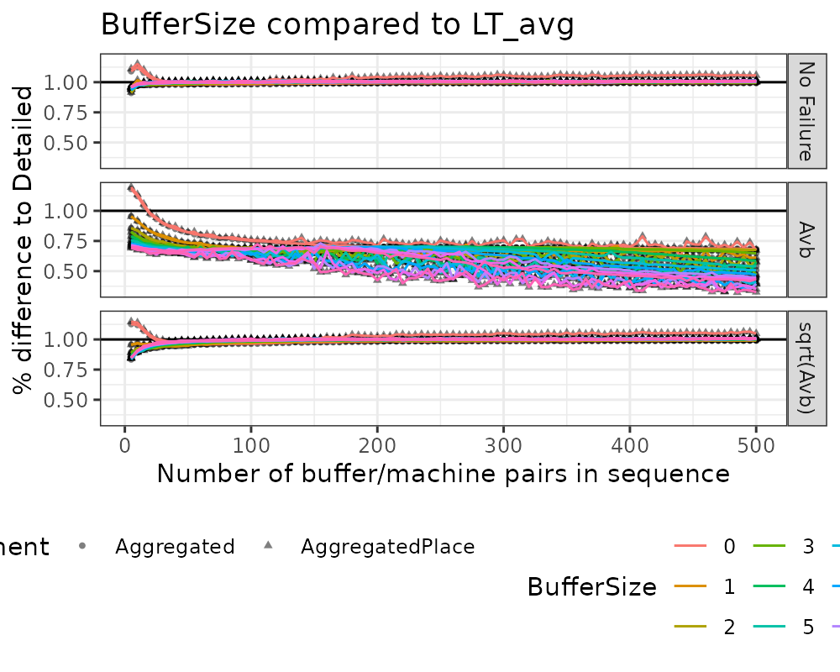

## WIP

### Avb 98

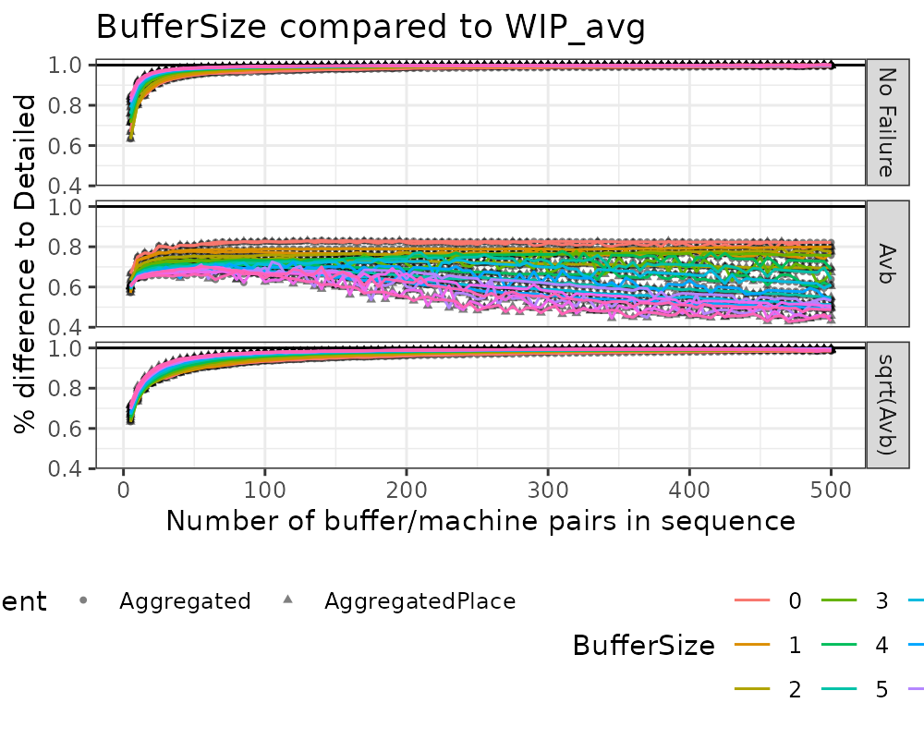

### Avb 85

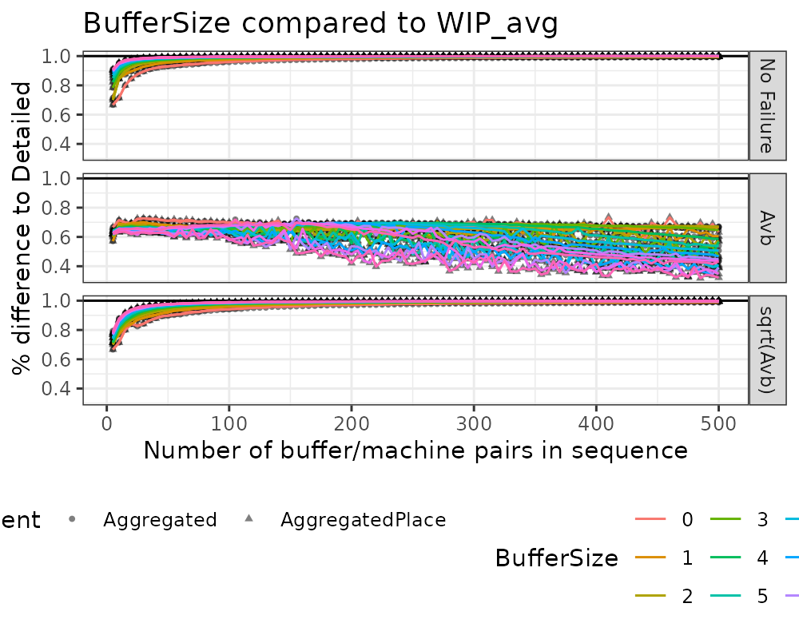

## JPH

### Avb 98

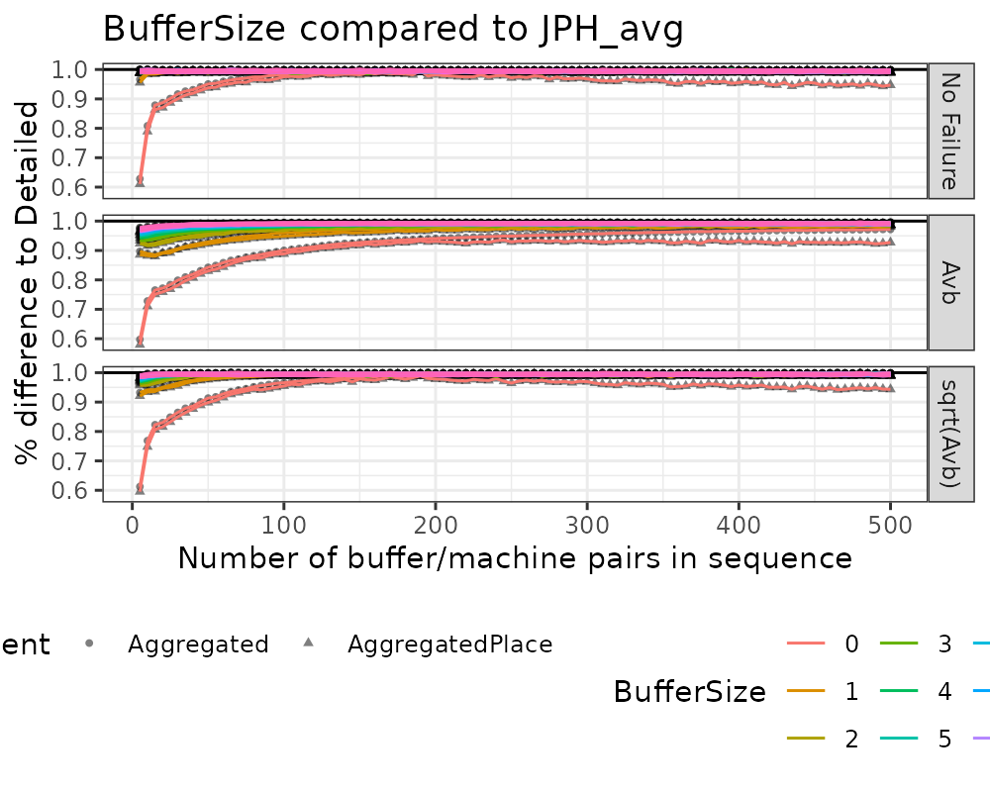

### Avb 85

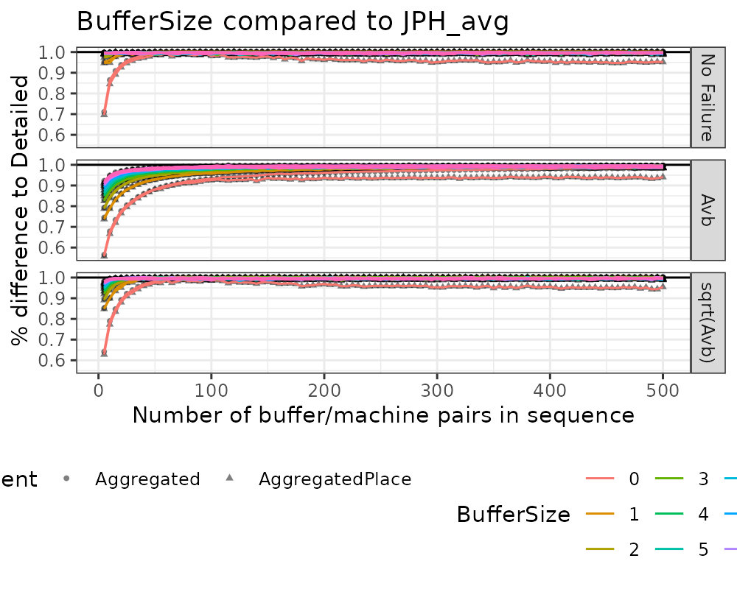

# Summary

*Aggregated* operates at near constant **Runtime** and does not scale with the size of the input parameters. *AggregatedPlace* increases with the size of the input parameters due to the functionality of PlaceBuffer.

*AggregatedPlace* does not increase the performance sufficiently to offset the increase in **Runtime**.

*AggregatedPlace* should therefore **NOT** be used.

**InputDistribution** performs worse or equal for all KPI’s.

# Next Steps

* How to evaluate the difference in values? No failure > sqrt(Avb) > Avb.
* Test parallel systems.

# References

Zee, Durk-Jouke van der. 2017. “Approaches for Simulation Model Simplification.” In *Proceedings of the 2017 Winter Simulation Conference*, edited by W. K. V. Chan, A. D’Ambrogio, G. Zacharewicz, Navonil Mustafee, Gabriel Wainer, and E Page, 4197–4208. Piscataway, New Jersey: Institute of Electrical; Electronics Engineers, Inc. <https://doi.org/10.1109/WSC.2017.8248126>.